**Entity Relationship Diagram for Employee Task Management System :**

**Title :** Employee Task Management System

**Purpose :** The purpose of the Employee Task Management System database is to efficiently track and manage tasks and assignments within an organisation. This system is designed to enhance productivity, streamline communication, and ensure that tasks are completed in a timely manner.

**Entities :** Total Number of Entities : Two

1. Employee

2.Tasks

**Relationships :** Total Number of relationships : One

1. The "assigned to" relationship between Employees and Tasks means that tasks are assigned to employees.

**Attributes :**

* Simple Attributes :

1.First Name

2.Last Name

3.Date_Of_Joining

4.Phone_No.

5.Alternate Phone_No.

6.Email

7.Password

8.Role

9.Title

10. Description

11.Due_date

12. Status

* Key Attributes :

1.Emp_id

2.Task_id

* Foreign Key :

1. Assigned_to

**Cardinality :**

1. Employee and Tasks Relationship:

Cardinality: One-to-Many (1:N)

Description: Each employee (one) can be assigned to multiple tasks (many).

2. Tasks and Employee (Admin) Relationship:

Cardinality: Many-to-One (N:1)

Description: Multiple (many) tasks can be assigned by one employee (admin) (one).

**ER Diagram :**

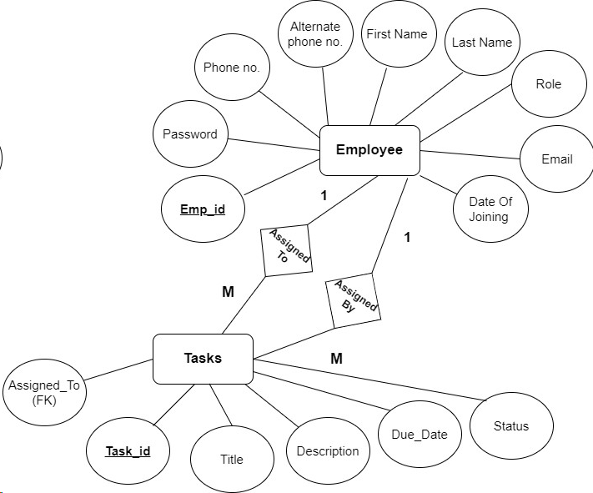

**Normalisation :**

**1st Normal Form (1NF):**

Employee and Tasks tables are in 1NF as they have a primary key defined for each table (Emp_id in Employee and Task_id in Tasks).

All attributes in the tables hold atomic values. There are no arrays, nested tables, or repeating groups, which would violate 1NF.

**2nd Normal Form (2NF):**

To satisfy 2NF, tables must first meet 1NF criteria, which both the tables do.

In the Employee table, there are attributes like First_Name, Last_Name, Date_of_joining, Phone_No, Alternate_phone, Email, password, and role. These attributes are all dependent on the primary key Emp_id. Therefore, the Employee table meets 2NF.

In the Tasks table, there are attributes like title, description, due_date, and status. These attributes are all dependent on the primary key Task_id, and the foreign key Assigned_to reference the Emp_id in the Employee table, which is the appropriate way to link the two tables. Therefore, the Tasks table also meets 2NF.

**3rd Normal Form (3NF):**

A relation is in 3NF if it is in 2NF and has no transitive dependencies, meaning that non-key attributes should not depend on other non-key attributes.

In the "Employee" table, there are no transitive dependencies. All non-key attributes are directly dependent on the primary key, "Emp_id." Therefore, it is in 3NF.The "Tasks" table is also in 2NF and 3NF because it has a primary key (Task_id), and the non-key attributes (emp, title, description, due_date, status) are directly dependent on the primary key.

**Database:**

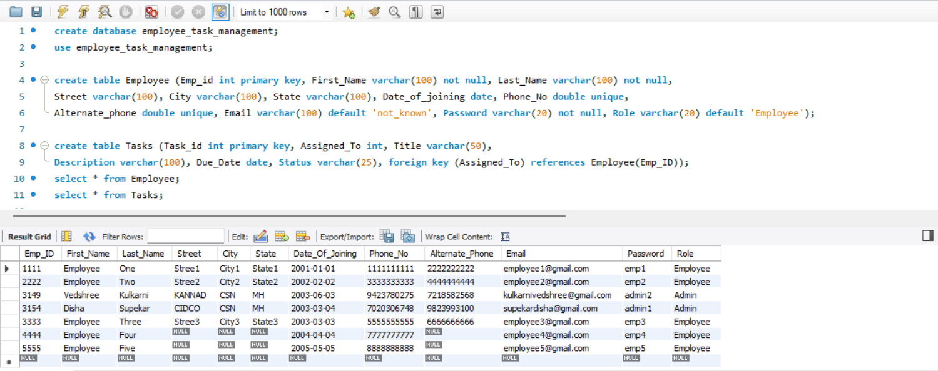

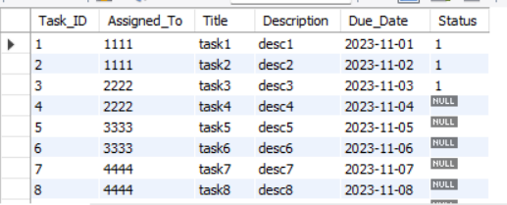

**Output:**

